**Name: _______________________________________ Partner: ________________________________**

**Python Activity 12: Void Functions**

|  |
| --- |
| **Learning Objectives**  Students will be able to:  *Content:*   * Explain the meaning and purpose of a function * Recognize a function definition, function header, and function call in a program * Combine the use of functions with if/else statements * Explain programs that use the same function multiple times * Use good test data for programs that include functions   *Process:*   * Write code that includes function definitions and function calls * Write programs that incorporate functions and if/else statements   **Prior Knowledge**   * Python concepts from Activities 1-11 |

**Critical Thinking Questions:**

|  |
| --- |
| **Python Program** |

|  |
| --- |
| **FYI:** A **function** is a segment of code that performs a single task.  A **function definition** is the segment of code that tells the program what to do when the function is  executed. The first line of a function definition is known as the **function header** |

1. Closely examine the Python program above.

a. What Python **keyword** is used to indicate that a code segment is a **function definition**?

_______”def”_________

b. What are the two **function headers** in the Python code?

__________”def printMessage():” and “def main():” are both of the function headers of both functions being called upon._________________

c. The name of the function is in the function header. What are the names of the two functions?

_____printMessage and main_______

d. Enter and execute the Python program. What is the output?

______________It says “Hello Programmer!”____________

________________________________________________________________________

________________________________________________________________________

e. What line of code would you add to the program to print the last two lines twice? Where would you add the code?

________Underneath the “main()” function, make sure you list the other name of the function (printMessage()), so that it runs that message as well.___________

________________________________________________________________________

2. Examine the following program

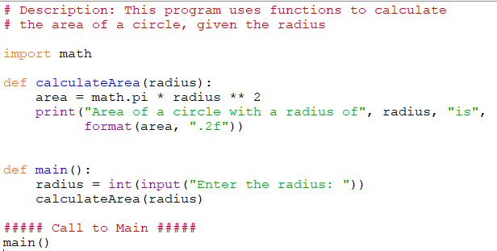

1. Label the **function definitions** and the **function calls**.

Functiondef=def and import

Functioncall=radius, math.pi, main, calculateArea

b. The function call and the function definition for *calculateArea* each include a variable within the parentheses. The variable in the function call is known as an **argument**. The variable in the function definition is called a **parameter.** What is the parameter in the function definition? What is its purpose?

________The parameter is the “calculateArea”(i.e. the variable of the definition)__it’s purpose is to store the information within a label for the use of being called upon in the future.__

c. In this example the parameter in the *function definition* and the argument in the *function call* have the same name. Is this required? __Yes, as it is calling that specific function definition.__

d. Enter and execute the program. Verify your answer to question ‘c’ by changing the variable name in the main function from **radius** to **number**. Do not change the parameter variable name in the function definition. Does the program still work? _No, number is not defined._

e. Write a line of code that calls the **calculateArea** function and sends the value “6” as the argument. Add the line of code to the main program and execute it to be sure it works properly. __calculateArea(6)__

f. Add another function to the program that calculates and prints the *diameter* of a circle, given the radius as the parameter. Place the function definition above call to the main function of the program. Write the function below.

________________________________________________________________________

________________________________________________________________________

________________________________________________________________________

________________________________________________________________________

g. Add another line of code to the main function of the program to call the function that was created in part ‘f’. Send the radius entered by the user as the argument to the function. ________________________________________________________________

3**.** Carefully examine the following program.

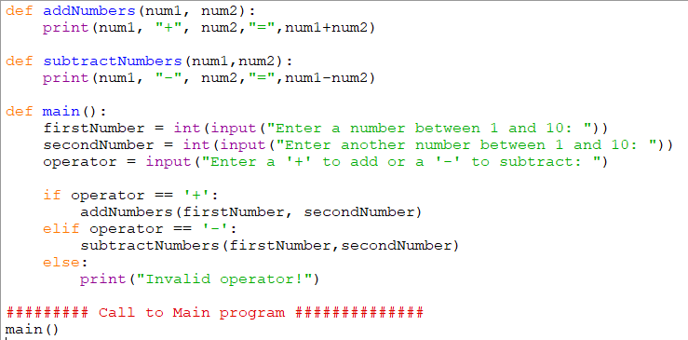

a. Place an “*” next to the first line of code executed by the Python interpreter.

b. Enter and execute the program using the data below. State the output for each set of data.

|  |  |  |  |  |
| --- | --- | --- | --- | --- |
| **Data Set** | **Operand 1** | **Operand 2** | **Operator** | **Result** |
| **1** | 2 | 6 | + |  |
| **2** | 3 | 8 | - |  |
| **3** | 34 | 23 | + |  |
| **4** | 4 | 5 | / |  |

c. What problems did you notice when you entered Data Sets 3 and 4?

________________________________________________________________________

________________________________________________________________________

________________________________________________________________________

d. Add code to the program that would warn the user about the problem that could occur when data similar to that in Data Set 3 and 4 is entered. See sample output below. Write the revised program below the sample output.

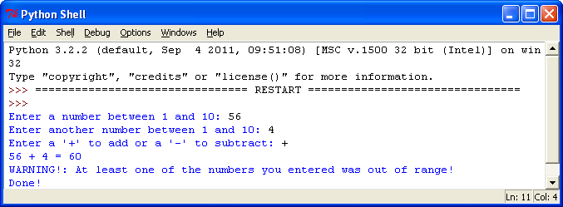

________________________________________________________________________

________________________________________________________________________

________________________________________________________________________

________________________________________________________________________

________________________________________________________________________

________________________________________________________________________

________________________________________________________________________

________________________________________________________________________

________________________________________________________________________

________________________________________________________________________

________________________________________________________________________

________________________________________________________________________

________________________________________________________________________

________________________________________________________________________

________________________________________________________________________

________________________________________________________________________

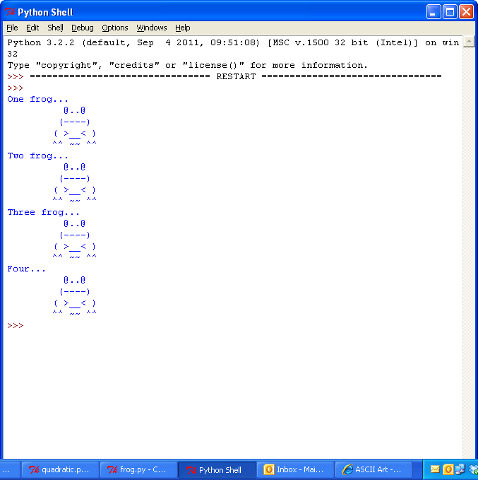**Application Questions: Use the Python Interpreter to check your work**

1. Write a function that draws a frog. Call the function to be sure it works. Sample frog:

______________________________________________________________________________

______________________________________________________________________________

______________________________________________________________________________

______________________________________________________________________________

______________________________________________________________________________

______________________________________________________________________________

______________________________________________________________________________

______________________________________________________________________________

______________________________________________________________________________

______________________________________________________________________________

______________________________________________________________________________

______________________________________________________________________________

2. Expand the program in #1 to produce the following output.



____________________________________________________________

____________________________________________________________

____________________________________________________________

____________________________________________________________

____________________________________________________________

____________________________________________________________

____________________________________________________________

____________________________________________________________

____________________________________________________________

____________________________________________________________

____________________________________________________________

____________________________________________________________